**World Rally Champion Loeb triumphant in Yokohama supported Mit Jet series**

The 8 times World Rally Champion driver Sebastien Loeb won the 14th July (Bastille Day) race of the Mitjet 2 Litre series, the one make race fitted with YOKOHAMA NEOVA 225/40 R18 supplied by YOKOHAMA France. Loeb also achieved a podium finish on his second race of the weekend crossing the chequered flag in second position.

The race took place in the International race track Magny-Cours, during the the main weekend of the French Car Championship, which is the country’s biggest series and includes prestigous races such as GT and Porsche cup.

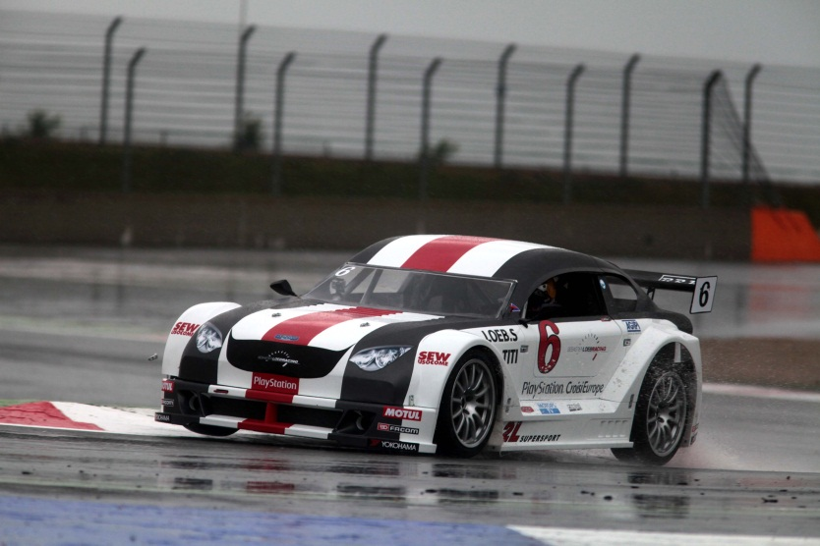

The event was very well attended, no doubt attracted by the likes of legendary drivers such as Sebastien Loeb, which meant hundreds of fans congregated in the paddock in search of a glimpse of the star and see him in action. YOKOHAMA had a very significant presence and the brand was well displayed in the mitjet series which boasts 60 cars in 1300cc and 20 cars in the new 2L serie.

At the end of the succesful weekend, a very satisfied YOKOHAMA France President Patrick Lhoste expressed he was very happy and proud to have such important International Champions such as Loeb participating in the event and highlighted the superb performance of the YOKOHAMA tyres in the challenging wet conditions.

YOKOHAMA is official tyre supplier for the Mit jet series.

**Notes to Editors**

**YOKOHAMA is one of the leading Tyre manufacturers in the world and is Official Tyre supplier for;**  
FIA World Touring Car Championship (WTCC) – since 2006  
European Touring Car Cup (ETCC) – since 2005  
Intercontinental Rally Challenge  (IRC) – since 2007  
Scandinavian Touring Car Championship (STCC) – since 2010  
Russian Touring Car Championship (RTCC) – since 2006  
Chinese Touring Car Championship (CTCC) – since 2010  
Irish Touring Car Championship (ITCC) – new for 2012  
International Formula 3 Grand Prix Macau – since 1983   
ATS German Formula 3 – until 2005 and since 2007

FIA F2 Championship – new for 2012  
Japanese Formula 3 – since 2011

ADAC GT Masters new for 2012

GT Asia new for 2012